
INVITATIONAL TRAVEL SUPPORT
For ORACLES Project

This document is intended to be utilized as a guideline for instructional purposes specific to ORACLES participants for summer 2016 travel. It is based on the Wyle Corporate Travel Policy and the Federal Travel Regulations (FTR), of which all travel expenses will be audited against for compliance.

Travel Process

Pre-Travel
Wyle can pay directly for airfare and Avis rental car if travel is booked via the Wyle Corporate Travel Agency, Travel Leaders. Lodging, M&IE (meals), and any other business travel expenses are the responsibility of the traveler and will be reimbursed as expense reports are submitted.
Prior to travel, approvals must be in place (written approval of travel estimates budget by Project Manager in charge of the project traveler is charging to, and Wyle Management approval). To utilize Travel Leaders for airfare and/or rental car, a Travel Profile must be created.

TRAVEL LEADERS Corporate Travel Profile Setup
- Create a Travel Profile at https://secure.futuretr.com/clients/profile.php
(See full instructions in the Travel Leaders Corporate Travel Profile Setup Guide table on page 4).
- Your Wyle Travel Coordinator (contact information on page 3) can book your airline tickets, hotel, and rental car on your behalf, or you may book with Travel Leaders directly.
  - Your personal credit card (as specified in your travel profile) will be used to hold your Hotel only.
  - Expenses will be reimbursed as Expense Reports are submitted to the Travel Coordinator for processing.
- Contact your Wyle Travel Coordinator via email to specify dates and communicate any specific requirements.
- The Wyle Travel Coordinator will confirm arrangements with you prior to booking.

Booking Guidelines & Restrictions
When requesting travel reservations via email, please remember to provide the following:

- Dates/times of travel Location(s)
- Please indicate if any personal travel/stay is included in the trip
- If a car rental is needed, please provide information on what days and times
- Indicate whether lodging accommodations via our agency are needed

See below for detailed on each category.

Airfare
- Nonrefundable coach/economy class tickets
  - We’ve approved a travel allowance for those traveling commercially to Namibia. This provides for one of the following during travel ‘over 14 hours’ (wheels up, home; to wheels down, destination):
    - A rest day upon arrival
    - An overnight hotel stay en route
    - Reimbursement for airport lounge use en route
    - Upgrade to next higher class of seat, e.g., premium economy where it is offered with approval from the ORACLES Project Manager
- Personal travel days are not reimbursable. If you have personal days added to your trip, it is required to inform your Wyle Travel Coordinator when booking.
  - A comparison airfare printout of the business only dates must be captured if the traveler is requesting Travel Leaders to book airfare on dates that lie outside of their Temporary Duty (TDY) approved business dates. This comparison must be done at the time the airfare is booked.

Personally Owned Vehicle (POV)
If you are claiming mileage for a POV, you will need to provide a Google map printout of the driven route to be included with your receipts.
- If your one-way POV mileage is more than 400 miles, a comparison printout for the lowest available non-refundable economy roundtrip airfare must be included with receipts. Reimbursement for mileage will be limited to that comparative airfare cost.
  - Not likely applicable to most ORACLES participants ask Wyle if you are in doubt.
- The current mileage rate is $0.54/mile (http://www.gsa.gov/portal/content/100715)
- You will not be reimbursed for insurance or repairs if you use your own vehicle.

Rental Car
ORACLES will be using a shuttle bus for most of the science team transportation. If you have approval from the ORACLES Project manager to rent a car in Namibia the highest allowable class of rental car vehicle is intermediate class. If a larger vehicle is needed, you will need prior approval from the ORACLES Project Manager.
- You will not be reimbursed for any add on features (i.e., GPS navigation devices).
- You must refuel the rental car before returning it to the car agency. If you choose to use the rental car company Fuel Service Option, you will not be reimbursed for that cost.
- For domestic travel, travelers will not be reimbursed for insurance provided by the rental car company.
    - Wyle invited ORACLES participants are covered under the Wyle insurance policy.
- For foreign travel, travelers will be reimbursed for the LDW (Lost Damage Waiver) insurance provided by the rental car company.

Hotels
Room blocks have been arranged with rooms. Please check with ORACLES Project Manager before making alternate arrangements, this is discouraged due to safety concerns and trying to keep everyone as centralized to the ops center as possible. You will pay for your hotel and then be reimbursed by Wyle.

Flying to and from Namibia on the P-3
If you will not be using a commercial airline service for the deployment you still need to reach out to Wyle. Please contact Crystal Gir at crystal.k.gir@nasa.gov (650) 604-4068. Inform her you are traveling for ORACLES and flying both ways on the P-3. She will setup your Travel ID so that you can be reimbursed for M&IE and other costs.

Additional Information
- Travelers will not be reimbursed for travel insurance through Wyle, other than the required Medical Evacuation Insurance for those traveling to Ascension Island.

Additional Reimbursements
The project will be covering the following non-travel costs:
- Any Notary fees for Namibia Visa Application process
- Cost for Medical Evacuation Insurance required for Ascension Island Travelers.
- Costs not covered by insurance for Required or Recommended Vaccinations for traveling to Namibia.

To be reimbursed for these costs you must submit a Check Request Form:
- Make check payable to:
  - Include your Full name
  - Use the mailing address where you want your check to arrive
  - Include your cell number/ no fax # needed
- Description: Enter amount under the corresponding expense row. Include subtotal and grand total.
- No signatures required. Wyle will get management signatures.

This can be submitted before you travel.

During Trip
Keep Original Receipts
- Receipts are required for Airfare, Lodging and Rental Car. All receipts require proof of payment. NOTE: For airfare and/or rental car booked through Travel Leaders, you will submit receipts as given by the agency. These receipts will not show a zero balance as they are billed to Wyle directly.
- You must submit receipts for all miscellaneous expenses (e.g., fuel, taxis, baggage fees, etc.).
- Receipts for meals are not required.
- International travel expenses need to be converted using a conversion rate published daily (oanda.com), and a printout of the conversion included with receipt submittal.

Meal Reimbursement
You will be reimbursed for M&IE based on the government per diem rate by location. Rates can be found at http://www.gsa.gov/portal/content/104877 for continental United States and Int’l: https://aoprals.state.gov/web920/per_diem.asp

- Travelers will be reimbursed 75% of the per diem rate for the first and last days of travel and 100% for the days between.
- If you are traveling directly from one TDY location to another, the appropriate M&IE per diem rate for the travel day is the rate associated with your destination (even if the travel day involves overnight travel). Exception: On your last day of travel, the appropriate rate is 75% of the M&IE per diem rate of your final TDY location.

Post-Travel Process
For deployment cost reimbursements complete the Professional Services Invoice form. When submitting the form, please make sure you scan all receipts and mail the originals to Daniel Mendoza (see contact info below). Original receipts being anything printed out, such as a taxi or shuttle receipt(s) — We do not require any meal receipts.

Please do not place your SSN on the form; contact via phone (For foreign nationals: passport number and expiration date )

Once you have completed the PSI and gathered all the supporting documents, please send the following:

- PSI Form (Signed by traveler; scan and send clear copy)
- Airline Ticket (If you received it from KBRwyle, still send the original copy the travel agent sent to you) NOTE: For accounting purposes, all travel reimbursement expenses have to be accounted for on the PSI, even if KBRwyle paid for the expense
- Hotel receipt — Ensure the receipt shows a zero balance
- Misc. receipts (Ex: Parking, taxi, gas, baggage and etc.) NOTE: Tips are covered at up to 20%
- Google Maps printout is required if requesting mileage reimbursement
- For international travel; please convert the currency & list the currency rate that was applied
- In the comments section of your PSI please indicate if your trip included any personal stay/travel
- Meals are paid at the Gov’t Per Diem rate. (1st and last days are paid at 3/4^{ths} )Go to: http://www.gsa.gov/portal/content/104877 to search for the rate in the area where you will be lodging; for international rates go to: https://aoprals.state.gov/web920/per_diem.asp
- Please tape small receipts to an 8 1/2 x 11 paper and send to the travel coordinator (see address below).
- Make sure all receipts shows proof of payment and are itemized. Points of Contact

Staying at Multiple Hotels
If you are spent the night somewhere on your way to or from Namibia, including the transits on the P-3 or are involved in a suitcase flight to Ascension Island you will need to put the grand totals into the PSI form and then provide a second spreadsheet that breaks out the costs per location and the per diem per location. Please see the samples at the end of the file.

Travel Coordinator:
Daniel Mendoza
650-604-2855
daniel.v.mendoza@nasa.gov
NASA Ames Research Center
Building N211, R320
Moffett Field, CA 94035-1000
Mail Stop: N211-31

Travel Leaders
If any changes to your travel arise during your trip, such as a missed flight or need to return home early, contact your Travel Coordinator or Travel Leaders at your earliest convenience to make changes in the reservation.
Travel Leaders POC: LeighAnn Puryear, puryearl@travelleaders.com
Phone: (281) 480-0111, ext.0111, or toll free at 800-544-4998
After Hours Phone: 800-823-0259

Direct Deposit
For those travelers that would like the automatic direct deposit fill out the Direct Deposit ACH Vendor Authorization Agreement form.

Useful Links

- Per Diem Rates: http://www.gsa.gov/portal/category/26429
- Per Diem Rates for international travel: https://aoprals.state.gov/content.asp?content_id=184&menu_id=78
- Per Diem Rates for Hawaii & Alaska: http://www.defensetravel.dod.mil/site/perdiemCalc.cfm
- International Currency Conversion: https://www.oanda.com/currency/classic-converter
- Travel Leaders Profile Set Up: https://secure.futuretr.com/clients/profile.php

TRAVEL LEADERS Corporate Travel Profile Setup Guide
Each traveler must submit a Travel Profile prior to traveling. Go to the following link: https://secure.futuretr.com/clients/profile.php
The items below do not cover all fields required since most of them are self-explanatory.
Is this a New Profile or a Revision?:
- Select “New Profile” if this is your first time signing up with TRAVEL LEADERS.
- Select “Revision” if you are updating your existing profile.
Name as it appears on Government issued ID:
- Fill out using your full first name (no nicknames)
- Work email should be entered (You will be able to enter your personal email later)
- Input “N/A” for both required fields asking for Manager/Supervisor information
TSA Secure Flight Required Information
- Date of Birth (Day/Month/Year)
- Redress number: Leave blank if you don’t have one. Click on the link for more information on “redress numbers”: http://www.dhs.gov/redress-control-numbers
- Known Traveler Number: Leave blank if you don’t have one. Click on the link for more information on “Known Traveler Number”: http://www.tsa.gov/tsa-precheck
Company Information
- Type “Wyle” under the “Company Name” field, and enter your business contact info.
Travel Planner – Enter as shown below:
- Name: Daniel Mendoza
- Email: daniel.v.mendoza@nasa.gov
- Ph: 650-604-2855
- (No Extension)
- Fax: 650-604-2929
For the following fields:
- Job Title: N/A
- Employee ID: Leave blank
- Department/Contract: Leave blank
- Division: N/A
- Site/Org Number: Leave blank
Credit Card
- Type your personal credit card info and this will be used for your hotel reservations.
Traveler Preferences
- Note: Preferences are based on availability.
Frequent Flyer Programs
- Add your “Preferred Departure Airport”.
- Add in all your Frequent Flyer numbers except for the rental car. Our preferred rental agency is AVIS and we will use our corporate account for the discount.

Sample PSI 1
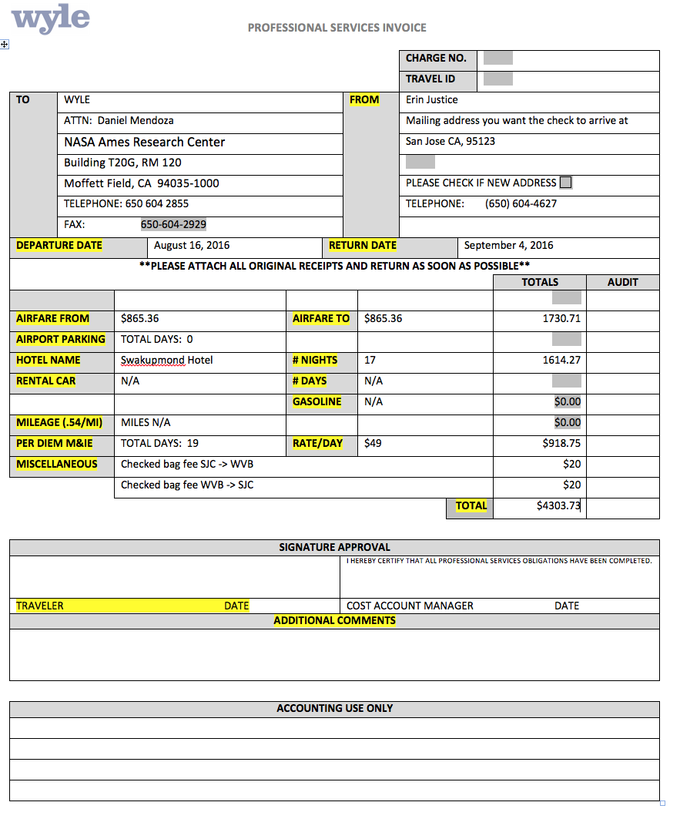

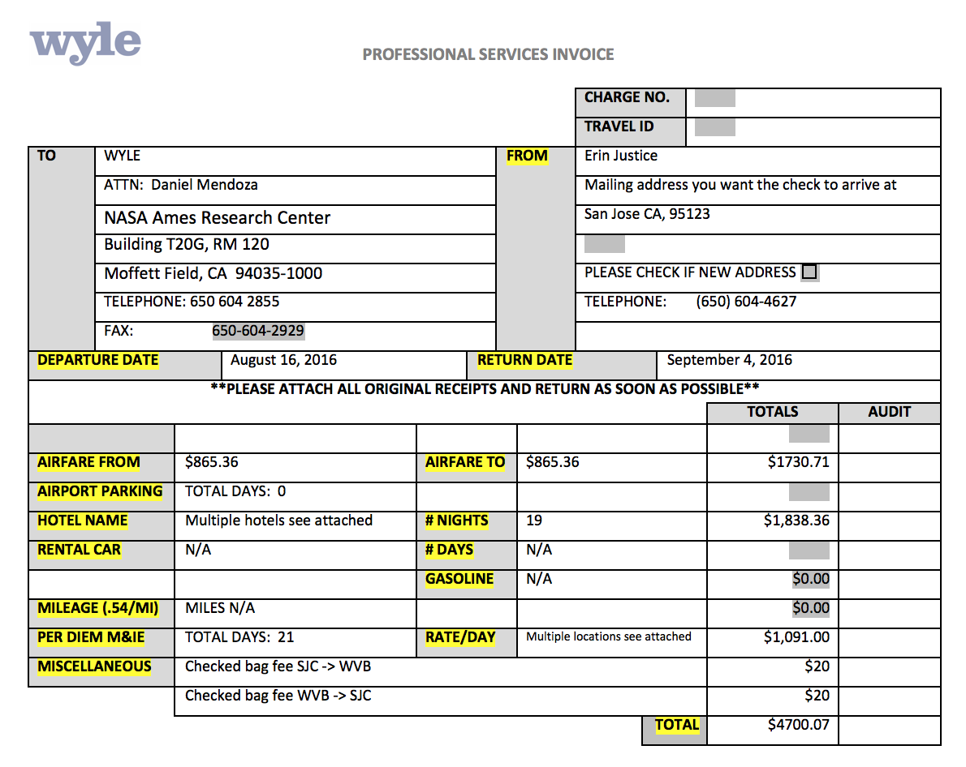
Sample PSI 2 with extra hotel stays

