Worksheet for estimation of INMARSAT

Ensure that mission occurs within the INMARSAT coverage area:
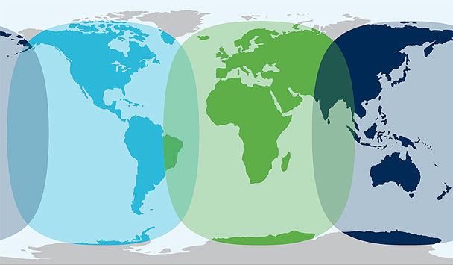

Section 1. Basic Communications

This section covers our basic system communications for aircraft tracking and communications.

Item | Yes or no | Nav Data To Ground | MB / Hour
IWG1 Data from Aircraft.  This data can be transmitted over Iridium, however use of the INMARSAT in conjunction with the Iridium provides a more consistent experience with fewer dropouts and a redundant channel. |  | 1 MB/hr
X-Chat  When flying on the manned aircraft within the INMARSAT coverage area, it is highly recommended that x-Chat be operated over the INMARSAT rather than Iridium. The reduced number of dropouts significantly improves the quality of communications |  | .5 MB/hr
Video Cameras  Assuming one snapshot every 5 minutes from the aircraft Forward Camera (DC8 and P-3B Only) |  | 3MB/Hr

Section 2. Instrument Telemetry Data

This section covers communication with otherwise autonomous instruments as conducted via either remote login protocols (SSH, telnet) or the Status Packet / User Packet paradigm as described in the Global Hawk Communications Guide.

Data Telemetry |  | Number of  Instruments | MB/Inst/  Hour | MB/Hour
Status Packets at 1/5Hz, per Global Hawk Communications Guide |  |  | .1
User Packets at 1/10Hz per Global Hawk Communications Guide |  |  | .2
SSH Access / Telnet Access |  |  | .5
Other Instruments, particularly scanners sending real time data may have other communications schemes. For a per-hour estimate on these items, please contact the data communications staff of the aircraft you will be flying on. |  |  | ?
Quicklook Products  Some instruments may want to transmit a quicklook product or image to the ground in place of raw data. Please list below.  Multiply Quicklooks per hour by Quicklook Size to get an estimate of bandwidth per hour for each quicklook type. |  | Quicklooks Per Hour | Estimated Quicklook Size* | MB/ Hour
1
2
3
4
 | Total MB Per Hour for Instrument Telemetry
* If quicklook size is unknown, assume around .25 MB per instance. This is safely high in most instances.

Section 3. Situational Awareness Ingest

This section covers the ingest of data onto manned platforms for purposes of enhanced situational awareness.

Item |  | Number of  Aircraft | MB/Aircraf/  Hour | MB/Hour
Ingest of other Aircraft Locations |  |  | X .1
 |  | Number of Instruments
Ingest of Instrument Time Series Data at ⅕ Hz |  |  | .1
Quicklook Products and Satellite Imagery -  This section should be used to determine how much bandwidth would be used to ingest real time imagery and quick looks into the aircraft. |  | Images Per Hour | Estimated Image Size * | Data in MB Per Hour
1
2
3
4
 | Total MB Per Hour for Situational Awareness Data
* If Image size is unknown, assume around .25MB per image. This is safely high in most instances.

4. Bandwidth Sensitive Streaming Applications
Some applications such as rocket telemetry and real-time streaming of full frame rate video may be bandwidth sensitive and require use of alternative INMARSAT Services. Please contact the appropriate data system staff for your aircraft for further information.

5. Total Bandwidth Estimation
Item | Bandwidth
Bandwidth per Hour From Basic Communications (Section 1)
Bandwidth per Hour From Instrument Telemetry
(Section 2)
Bandwidth per Hour from Quicklooks and Situational Awareness
(Section 3)
Add rows above to arrive at total bandwidth:
Total Bandwidth Per Hour
Multiply Total Bandwidth by 5.88 to arrive at a cost per flight hour:

